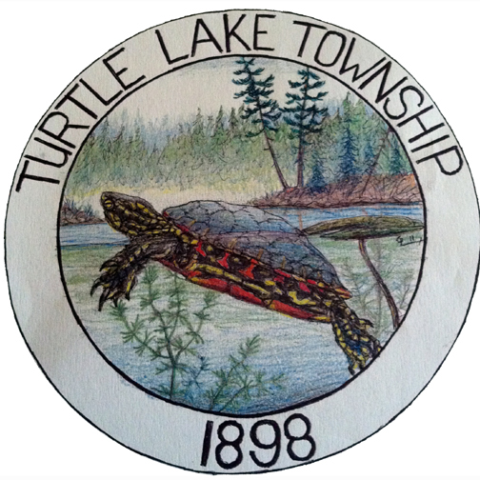

TURTLE LAKE TOWNSHIP ROAD TOUR AGENDA
May 24, 2019 at 10:00 a.m.
MEETING LOCATION – Lake’s Market 13477 Irvine Avenue NW

- Meet at Lakes Market parking lot.
- Tour all township roads and document potential work needed.
- Discussion of road tour findings will occur at the regular scheduled township meeting June 3, 2019 at 7 pm in the Turtle Lake Town Hall.

